REST - Get country based on country code

Write a REST service that returns a specific country based on country code.  
The country code should be case insensitive.

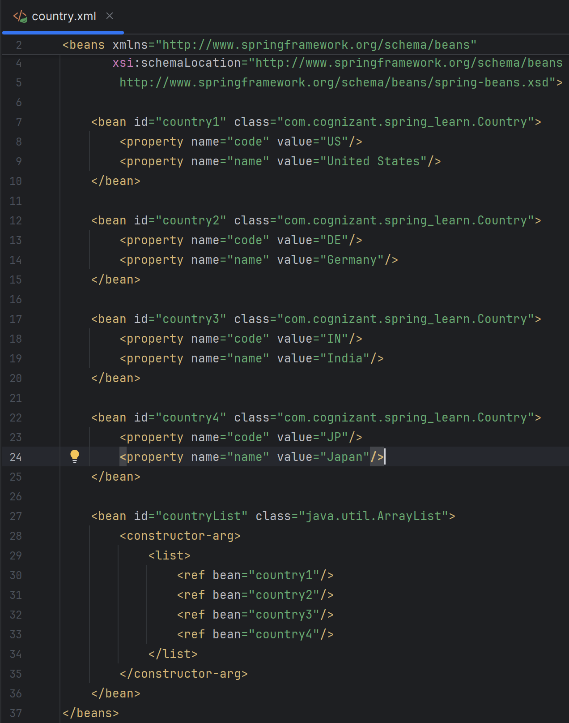**Step 1**: **Updating** the **country.xml** to have a list of countries.

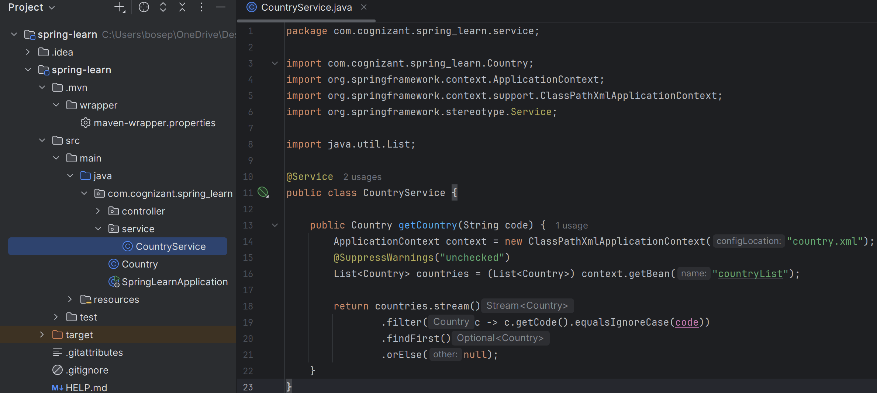**Step 2**: Creating **CountryService** class under a separate package named “service”

The above class :

▪ loads **countryList** bean from XML

▪ uses **lambda & stream** to find country case-insensitively.

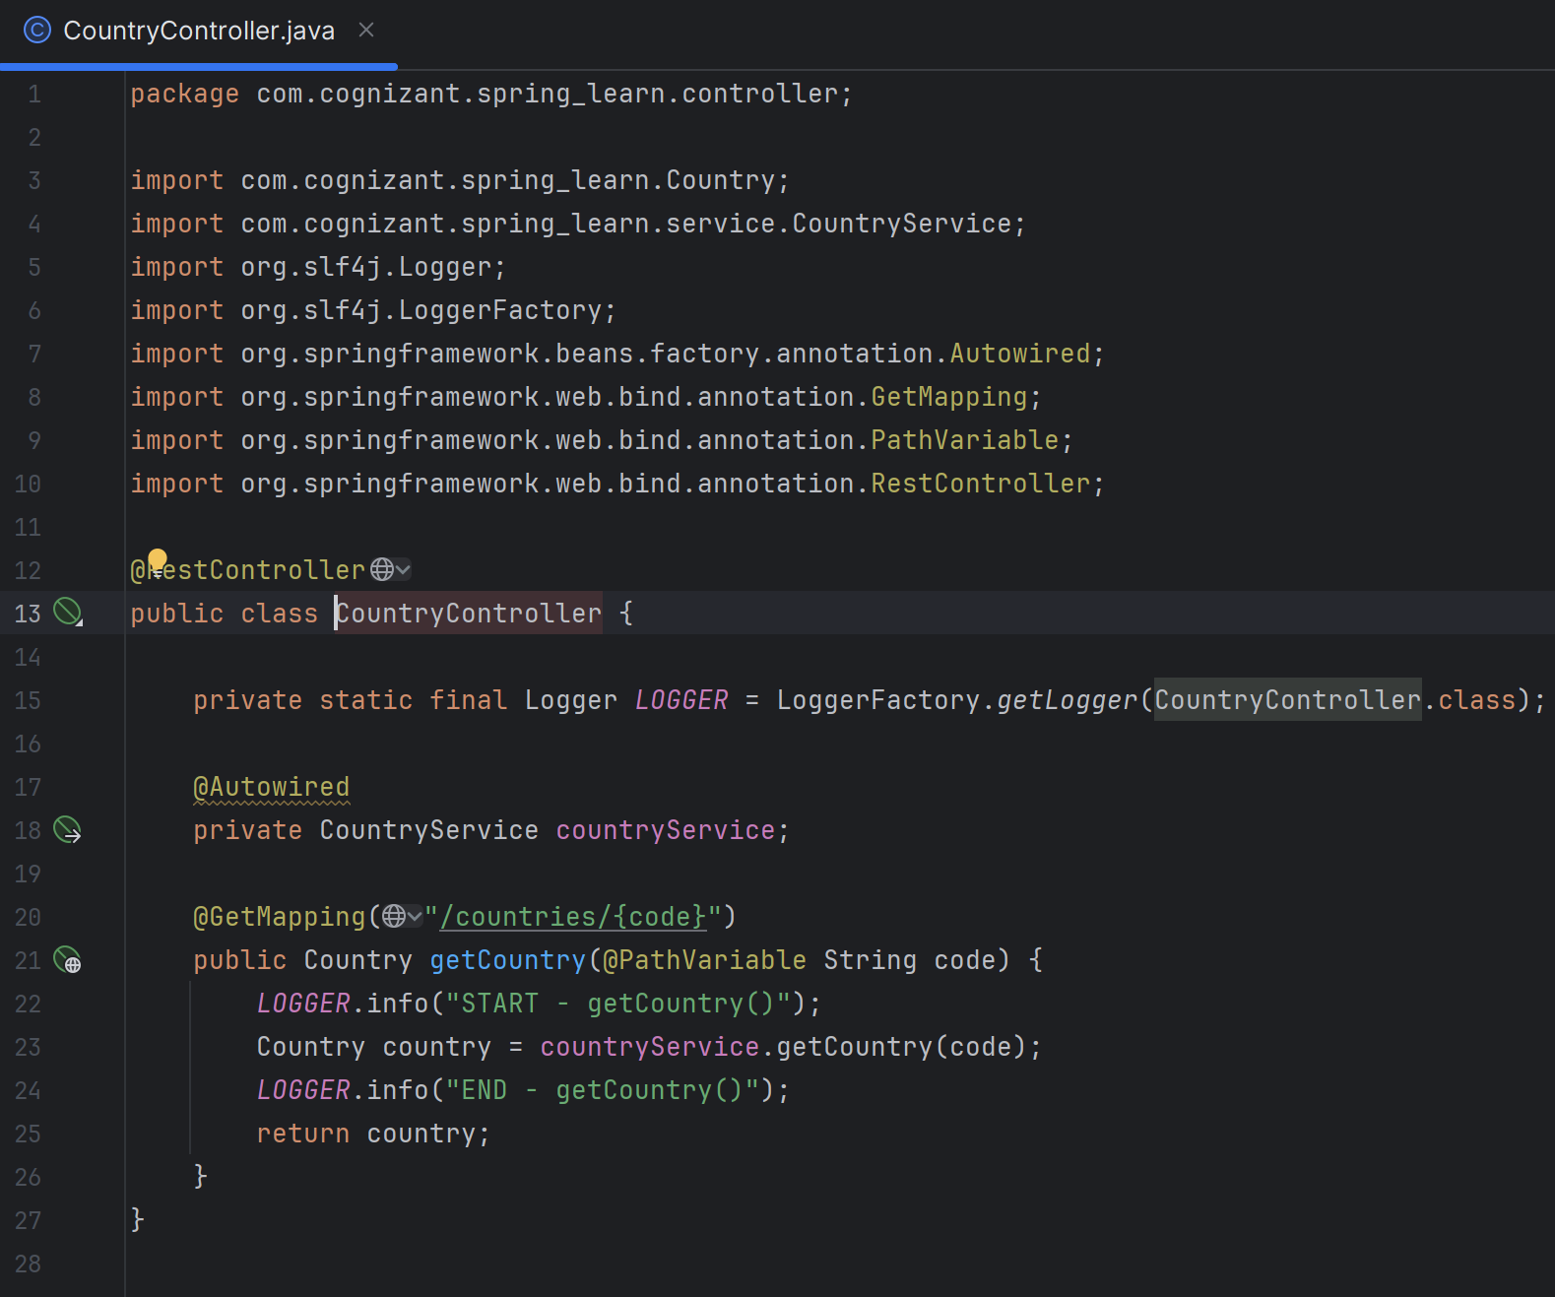**Step 3**. Created **CountryController** class

**Step 4**: Sample test in Postman 🡪

***********************************************************************

